**Code for chapter 8**

**Ex 8.1**

**Straight line model**

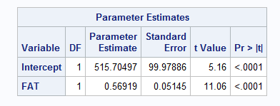

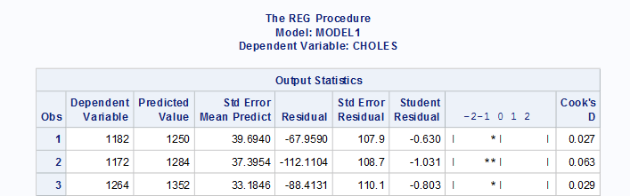

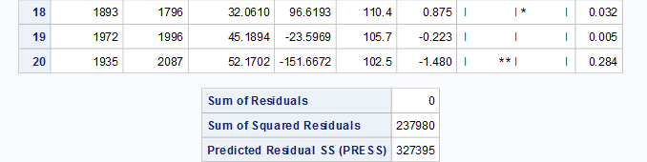

**Quadratic model**

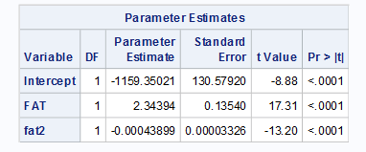

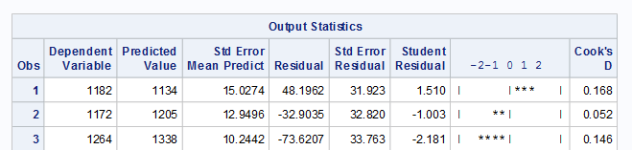

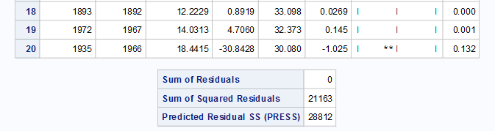

**data** olympic;

set 'C:\Users\yusha\Desktop\TEACHING\stat2223\my own\SAS\SAS\Exercises&Examples\OLYMPIC.sas7bdat';

**run**;

**proc** **print** data=olympic;

**run**;

**data** olympic2;

set olympic;

fat2=fat\*\***2**;

**run**;

**proc** **reg** data=olympic2;

model choles=fat/p r;

model choles=fat fat2/p r;

plot choles*fat;

**run**;

**Ex 8.2**

**Straight line model**

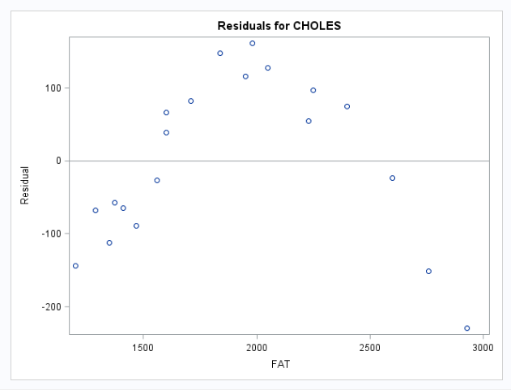

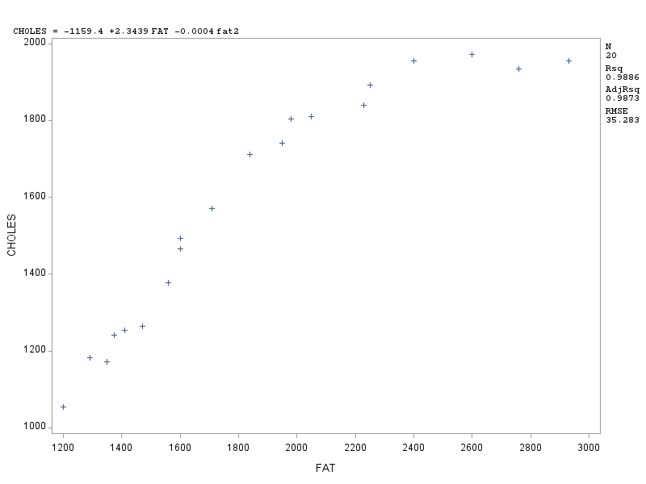

Using the same code as in ex8.1

**Ex 8.3**

**Quadratic model**

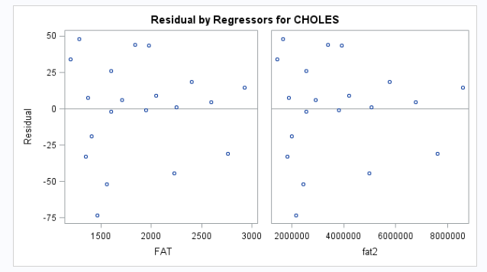

Using the same code as in ex8.1

**Ex 8.4**

*For model E(y)* = *β*0 + *β*1\**price* + *β*2*\*X*

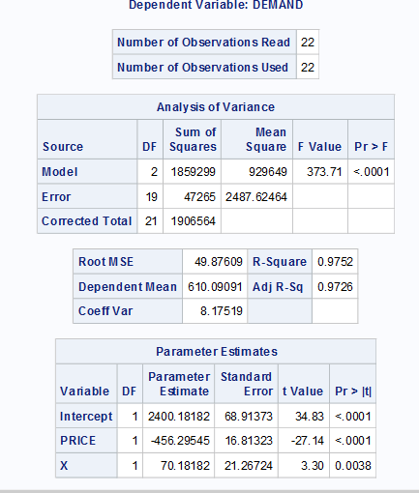

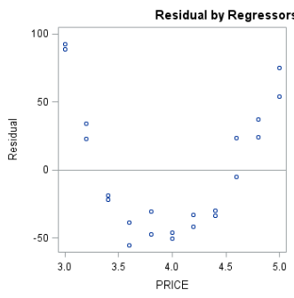

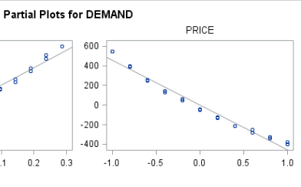

Introduce x1=(1/price ) as a predictor

*So now the model is E(y)* = *β*0 + *β*1*x*1 + *β*2*x*2, where *x*1 = 1*/p*.

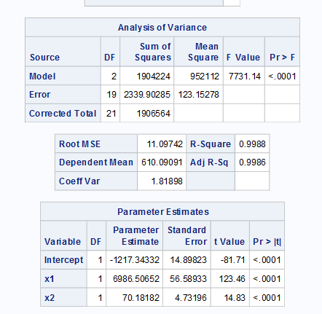

**data** COFFEE2;

set 'C:\Users\yusha\Desktop\TEACHING\stat2223\my own\SAS\SAS\Exercises&Examples\COFFEE2.sas7bdat';

**run**;

**proc** **print** data=COFFEE2;

**run**;

**proc** **reg** data=COFFEE2;

model DEMAND=PRICE X/r partial;/*draw residue and partial residue plot*/

**run**;

/*introduce x1=1/p into model*/

**data** coffee3;

set COFFEE2;

x1=**1**/PRICE;

x2=X;

**RUN**;

**proc** **print** data=COFFEE3;

**run**;

**proc** **reg** data=COFFEE3;

model DEMAND=x1 x2/r partial;

**run**;